LAB 15
Transactions

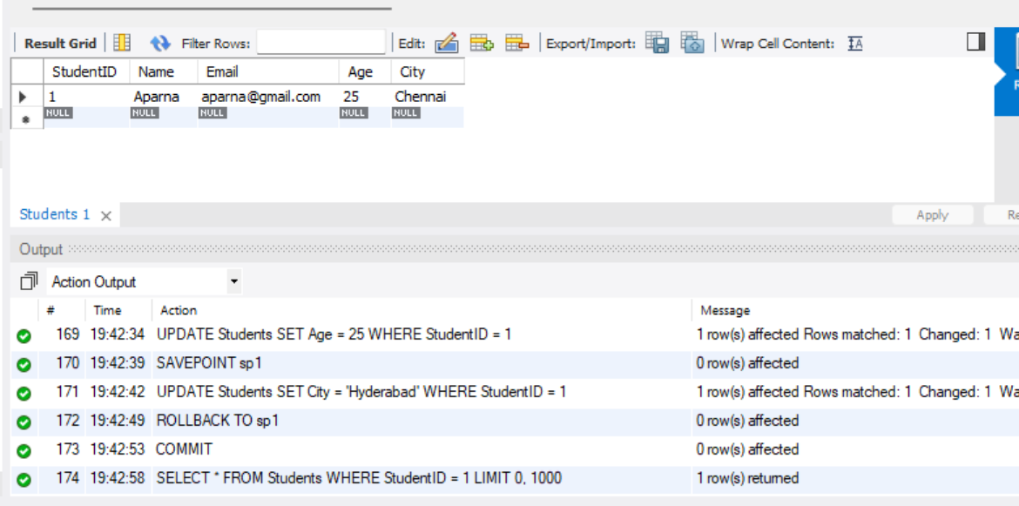

1. START TRANSACTION: Begins a new transaction.
2. UPDATE Age: Changes the age of the student with StudentID 1 to 25.
3. SAVEPOINT sp1: Creates a savepoint to which the transaction can be rolled back.
4. UPDATE City: Changes the student's city to Hyderabad.
5. ROLLBACK TO sp1: Cancels the city update and restores the city value to its previous state.
6. COMMIT: Saves the age update permanently.
7. SELECT: Displays the student's record with Age as 25 and the original City value

